Coal

Lab no 2

# Jeevan kumar (24k-0821)

Qno 1

INCLUDE Irvine32.inc

.data

_name BYTE "Jeevan kumar" ,0

_rn BYTE "24k-0821", 0

_sec BYTE "BCS-3C",0

_course BYTE "COAL LAB",0

.code

main PROC

mov edx,offset _name

call Writestring

call crlf

mov edx,offset _rn

call Writestring

call crlf

mov edx,offset _sec

call Writestring

call crlf

mov edx,offset _course

call Writestring

exit

main ENDP

END main

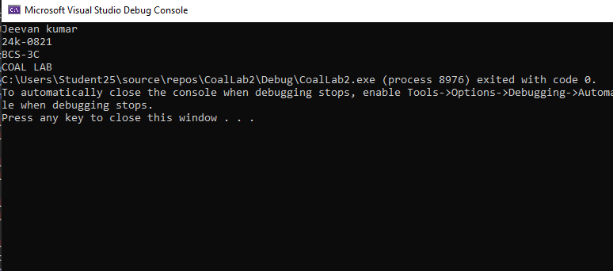

Qno 2

i)Code{

INCLUDE Irvine32.inc

.data

result DWORD ?

.code

main PROC

mov eax, 47

add eax, 39

add eax, 60

add eax, 85

add eax, 64

add eax, 44 ; octal 54

sub eax, 10 ; hex 0A

mov result, eax

mov eax, result

call WriteDec

call Crlf

exit

main ENDP

END main

}

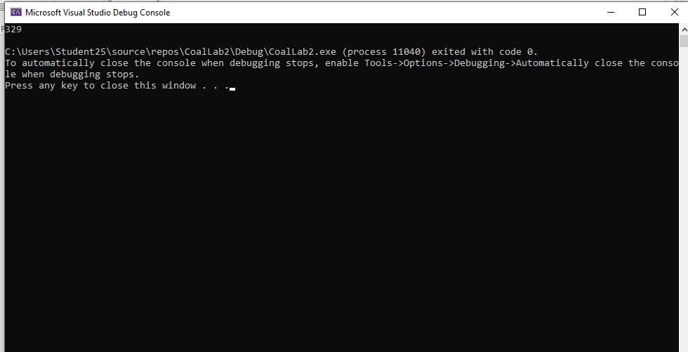

Qno 2

ii)Code{

INCLUDE Irvine32.inc

.data

result DWORD ?

.code

main PROC

mov eax, 30

sub eax, 9

add eax, 186

sub eax, 150

mov result, eax

mov eax, result

call WriteDec

call Crlf

exit

main ENDP

END main

}

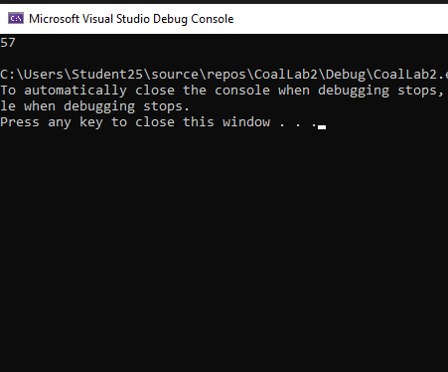

iii)Code{

INCLUDE Irvine32.inc

.data

result DWORD ?

.code

main PROC

mov eax, 46 ; 101110 binary → 46 decimal (converted)

add eax, 1290 ; 50Ah hex → 1290 decimal (converted)

add eax, 6710 ; 6710d decimal (already decimal)

add eax, 81 ; 1010001 binary → 81 decimal (converted)

add eax, 15 ; F hex → 15 decimal (converted)

mov result, eax

mov eax, result

call WriteDec

call Crlf

exit

main ENDP

END main

}

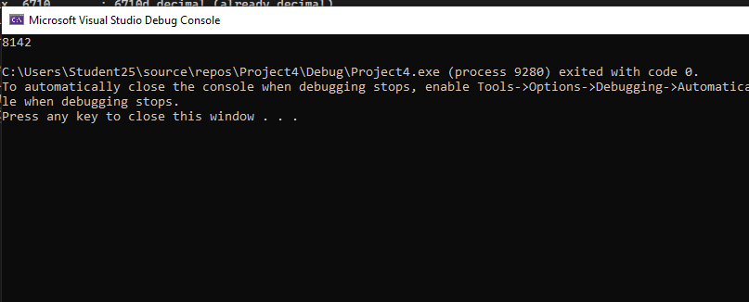

iv){ INCLUDE Irvine32.inc

.data

result DWORD ?

.code

main PROC

mov eax, 141 ; 10001101 binary = 141 decimal (converted)

sub eax, 3459 ; D83h hex = 3459 decimal (converted)

add eax, 385 ; 385 decimal (already decimal)

add eax, 125 ; 1111101 binary = 125 decimal (converted)

sub eax, 14 ; E hex = 14 decimal (converted)

add eax, 15 ; F hex = 15 decimal (converted)

mov result, eax

mov eax, result

call WriteDec

call Crlf

exit

main ENDP

END main}

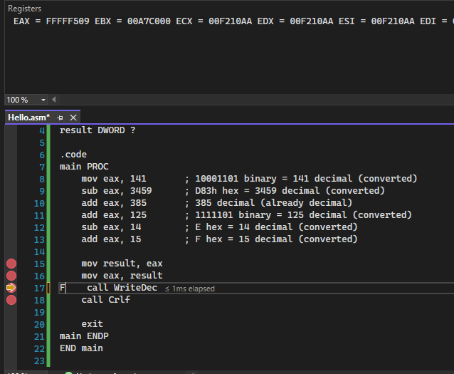

Qno3

i)Code {

INCLUDE Irvine32.inc

.data

.code

main PROC

mov eax, 10

mov ebx, 20

mov ecx, 5

mov edx, eax

add edx, 1

add edx, ebx

sub edx, ecx

add edx, 10 ; 0Ah hex = 10 decimal

sub edx, 53 ; 65o octal = 53 decimal

add edx, 73 ; 73 decimal

mov eax, edx

exit

main ENDP

END main

}

Output: 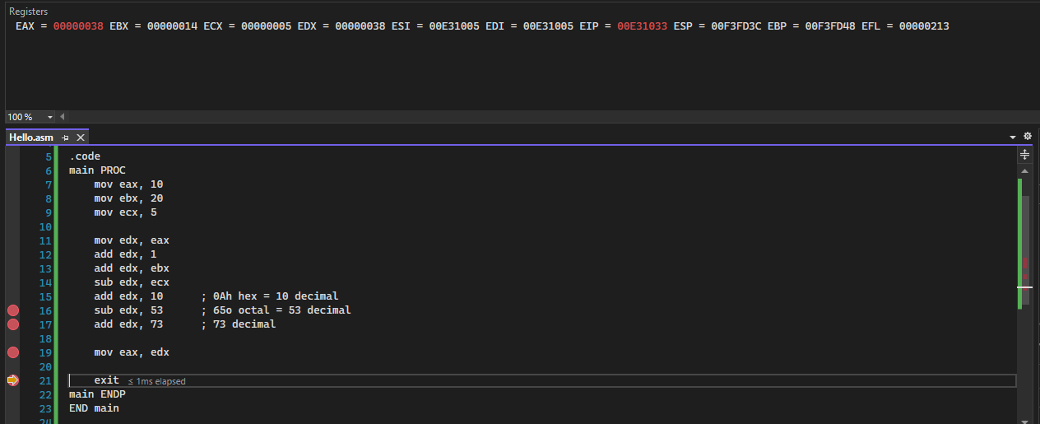

ii)

Code:{ INCLUDE Irvine32.inc

.data

.code

main PROC

mov ebx, 100 ; example value

mov eax, 1453 ; 5ADh hex = 1453 decimal

sub eax, ebx

add eax, 53 ; 65o octal = 53 decimal

add eax, 65 ; 65 decimal

sub eax, 247 ; 11110111 binary = 247 decimal

add eax, 150 ; 150 decimal

exit

main ENDP

END main

}

Output: 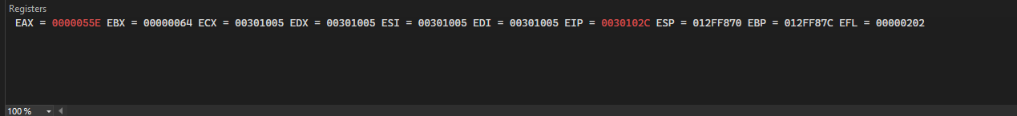

iii)

Code{ INCLUDE Irvine32.inc

.data

.code

main PROC

mov eax, 200

mov ebx, 1453 ; 5ADh hex = 1453 decimal

sub ebx, eax

add ebx, 65 ; 65 decimal

add ebx, 59 ; 73o octal = 59 decimal

sub ebx, 229 ; 11100101 binary = 229 decimal

add ebx, 123 ; 7Bh hex = 123 decimal

exit

main ENDP

END main

}

Output: 

iv)

Code:{

INCLUDE Irvine32.inc

.data

.code

main PROC

mov ebx, 50

mov ecx, 30

mov ecx, 6475 ; 1100101011011b binary = 6475 decimal

add ecx, 69 ; 45h hex = 69 decimal

sub ecx, 59 ; 73o octal = 59 decimal

add ecx, ebx

sub ecx, ecx ; ecx - ecx = 0 (cancels out)

add ecx, 1

exit

main ENDP

END main

}

Output:

